**User Centered Web Engineering**

001126108 | Big Data and Business Intelligence

coursework report

Abdullah Bin Zubair

2020

Table of Contents

Statement of the functionality 2

Employer account 2

Worker account 2

Project Specification: 3

Project Work Plan: 3

Phase 1: Design and Analysis 5

Questionnaire 5

Persona 8

Use Case 9

Task Analysis 9

Card Sorting 10

Similarity Matrix: 10

Dendrogram: 11

Prototype 12

Evaluation 13

Treejack 14

Navigation task results 15

Design Decisions 17

Phase 2: Implementation 18

Heuristic Evaluation: 18

Employer account 21

Worker account 21

References: 22

Code references: 22

# Statement of the functionality

After we had the user data generated by our studies, we needed to design a layout which would present the information architecture in a way that is acceptable and convenient for most of our users. We implemented all the features that were mentioned in coursework specification; account creation and login; time banking related functionalities and usability of website. Besides the required functionality, there were many more things which were implemented, some are mentioned in ‘design decisions’ section of phase 1 and other would be visible on the actual website.

### Employer account

Username: test -------- Password: test

### Worker account

Username: worker1-------- Password: 111111

# Project Specification:

In this report, we are going to do requirement gathering for a Time Banking website and its implementation following the UCD lifecycle. A ‘time bank’ is generally a community-run system where the time (e.g. hours) to deliver a particular task/service is the unit of the account – not the currency as in traditional bank. If this service could be provided online via a website, then it can enable various pending (because of the current circumstances) household tasks’ completion (e.g., plumbing, joinery work, carpentry, roof work, painting, gardening, tutoring of children) by utilizing skills and manpower that exist within its own community. Basic functionality has been finalized (according to coursework specification) as follows:-

* Visitors will be able to register with the site as members.
* Provide information about their skills; and required services/tasks via posts.
* Casual visitors to the site will be able to search through the posts to see if any posts are of interest to them.
* While any visitor can search through the various posts, full details of the registered time bankers/members (i.e., contacts) and their posted tasks’/services’ details will only be available after registering to this web site.

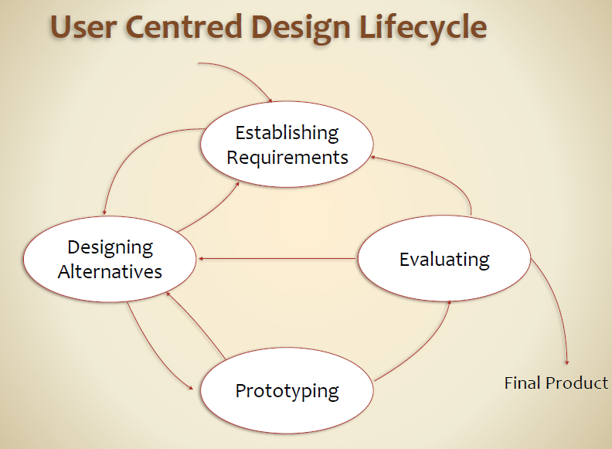

Figure 1 - UCD Lifecycle

# Project Work Plan:

There will be 2 phases for this UCD process. In Phase 1 we are going to apply several requirement gathering techniques involving the users as followed in UCD life cycle. In this report, we will be looking at 3 kind of methods/tools for requirement gathering then apply that knowledge to build different design artefacts for analysis and discussion. In Phase 2 we will develop a prototype which will provide working of some of the functionality principles. Finally we will evaluate the built prototype on basis of one of the two techniques, participant-based or heuristics evaluation.

**Phase 1:**

* First we create a **Questionnaire** in which we will get to know about the demographic of our audience/users and other key information about them which will help us build a **Persona** for our analysis and future reference.
* Secondly we will dive deep into the technical side of our website and focus on its information architecture, layout and navigation. We will discuss one of many **Use Cases** for our site and also analyze a task using **Task Analysis** diagram. We will conduct another study - **Card Sorting**. This will let us know about our grouping of things, which content needs to be with which is decided through this activity.
* Then we will design a **Prototype** (low fidelity/mockup) for one part of our website, a really important part. After that we will evaluate that prototype on basis of information gathered by the previously done research studies i.e. survey, card sorting etc.
* For any task there are specific number of steps to be followed in order to get it done. Finally, using an online tool **Treejack**, we will evaluate our navigation system designed for this website.

**NOTE:** We will use data from a maximum of 10 users who will be part of these studies. Based on the findings we will develop our first Prototype. This is the only limitation in this project.

**Phase 2:**

* We will develop a website based on our findings and teachings of UCD process.
* Then we will try to add other important features which might not be the requirement for this coursework but are really important for this website according to the users’ data such as the messaging service.
* Finally we will raise key points regarding those particular areas of website where improvement is necessary or recommended. This means that we might go back to designing alternatives stage according to the situation and treat our website as our second prototype (high fidelity). *optional*

# Phase 1: Design and Analysis

## Questionnaire

In order to get a clear picture of what our users’ needs are, we formulated a questionnaire. Each question represents some kind of query that the research team has and getting its answer from users helps to eliminate that particular issue. Questionnaire was built and spread with help of online tool called **Optimal Workshop [1].**

Following you will see every question answered by the users in analytical form with percentage of users who picked particular option and their frequency.

1. What is your age group?

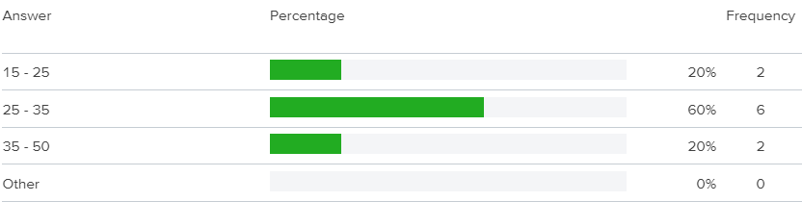

1. Which social media platform do you want your Time Banking account to be connected with?

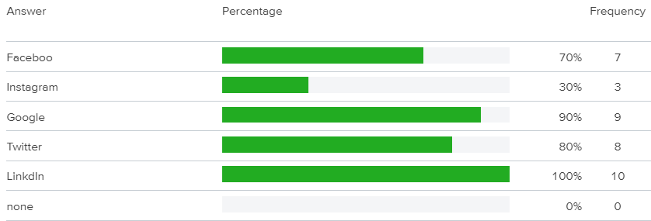

1. Would you appreciate information on the homepage regarding how the website works and FAQ section?

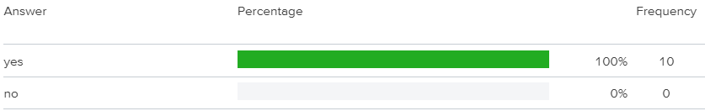

1. Messaging service is important for this website. Do you agree?

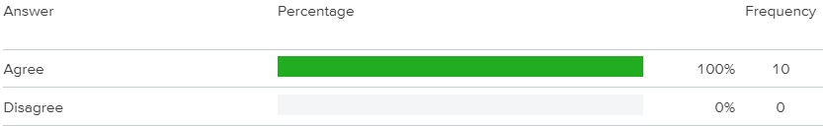

1. Would you be interested in a Time Banking website as:

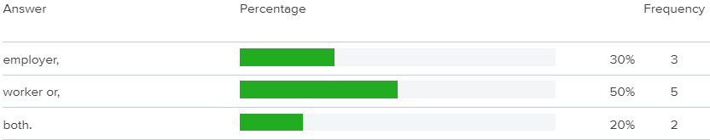

1. In Time Banking website the time (hours) to deliver a particular task/service is the unit of the account, not money. At any point would you like to sell your earned hours to an employer or worker in exchange for real money?

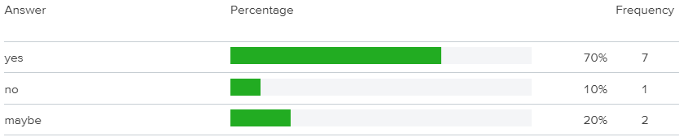

1. What information should be visible for a particular employer or worker?

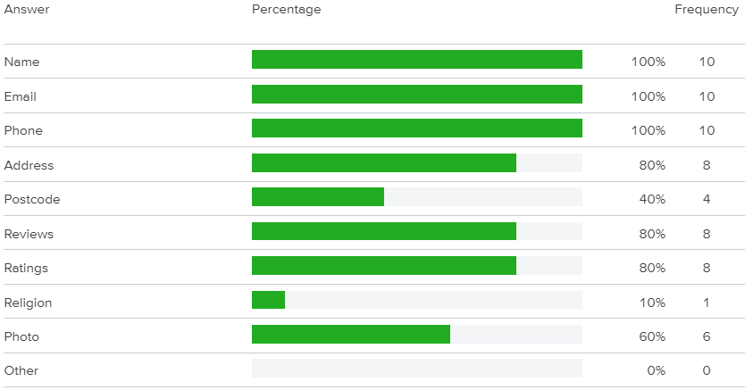

1. What specific information should be visible for any worker?

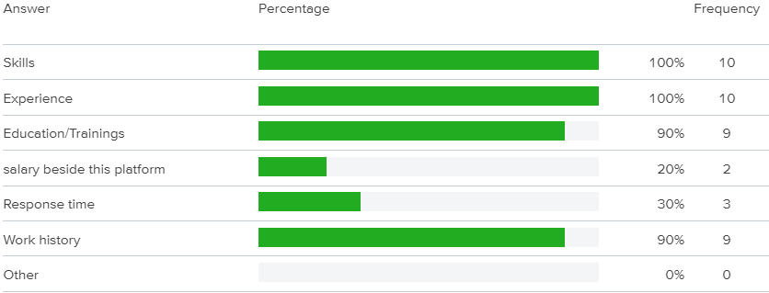

1. What specific information should be visible for any employer?

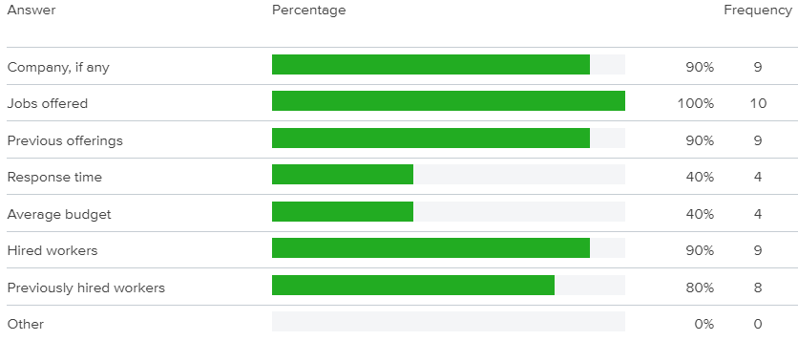

1. Is there anything specific that you need or want in this website? Feel free to share with us.

* “Everything should be in working condition.”
* “Should be easily useable on phone.”
* “Please do not add any background song or ads.”

**NOTE:** The implementation that reflect findings from each set of data gathered is justified under section ‘Design Decisions’ later in this report.

## Persona

***“Personas are fictional characters, which you create based upon your research in order to represent the different user types that might use your service, product, site, or brand in a similar way.”* [2]**

Following you will see a Persona which is formulated on basis of user data that we collected through our Questionnaire and the guidelines presented in coursework specification:-

Nancy Roberts

32 years old – Female - House wife

Nancy is a house wife who is living in Greenwich, London which is a very friendly and calm community. She lives with her family which comprises of her 2 children and her husband. Most time of the week her husband is out of town for work and thus she has to maintain the household and deal with all kinds of stuff that happens in a house. Due to the covid-19, many services are discontinued and it has been very difficult to find right labor for a specific job. She wants a platform where everyone can share their skillset, for her which is cooking, and make benefit from each other in the surrounding community. Work can be of any form i.e. plumbing, joinery work, carpentry, roof work, painting, gardening, tutoring of children etc. In order to maintain a friendly environment, she wants the currency to be calculated in hours but not in actual money. This means that if she can deliver 1 hour of service to someone, she also get a service of 1 hour for any of her jobs. She wants that her account should be connected to her social media so people can easily find her there. Nancy wants a platform where she can easily get details of jobs posted and details about who posted it so that she can view the whole picture.

Needs

* Post jobs and get services
* Browse all jobs posted by others
* Apply for relevant jobs
* Want to use time as currency, not money

Ideal Features

* Account management
* Profile management
* Connected social media
* Guide and FAQs section on site
* Messaging service on site
* Separate worker and employer profiles

Frustrations/Pain points

* Slow and buggy user interface
* Irrelevant information
* Advertisements

## Use Case

Use cases are often based on personas and scenarios. They can be described as functionalities in a particular system. There can be hundreds of use cases for one website. Analyzing these use cases helps developers plan their information architecture and manage their services on website. Below you will see a use case diagram for this time banking site. These are the core functionalities of employer and worker as these 2 are the only users of our system.

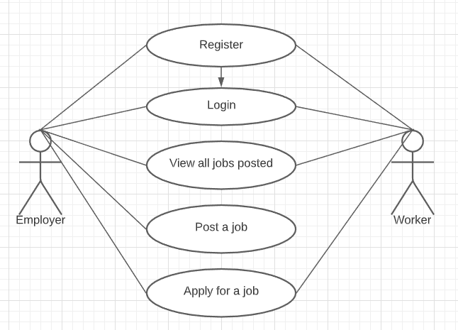

Figure 2

## Task Analysis

Task analysis diagram is basically a flow chart which represents the number and order of steps taken to fulfill a specific goal. For example there could be a task analysis diagram for buying a DVD or there could be a task analysis diagram to post a job on some website. Below you will see a task analysis diagram for the time banking website which describes the steps taken to fulfill a particular goal which is ‘Applying for a job’.

**Note:** In this case the task needs to be done only after logging into the system though it is written in the coursework specification that jobs can be browsed even without registering so this feature would obviously be implemented in the website too.

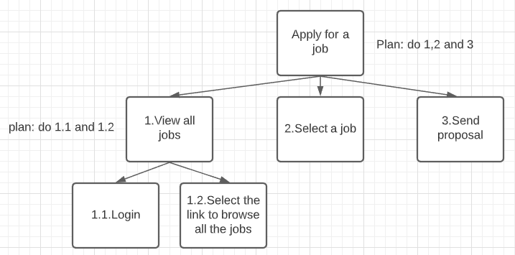

Figure 3

## Card Sorting

More often than sometimes users need to find a specific piece of information in the website but they struggle to find it. Now if a website have millions of users and this problem is same for each one of them, this can cause reduction in visitors which inevitably causes huge losses and missing out on potential revenue. To help users find what they are looking for, a simple process of card sorting was introduced. Card sorting is a powerful technique used by experts all over the world to find out how other people would group and label content on their sites. Understanding these patterns helps you organize information in a way that makes sense to people using your products.

For our specific Time Banking website, we organized another study using **Optimal Workshop [1].** The cards we created for the website are as follows:-

* Apply for job
* Employer details
* Employers
* FAQs
* Guide
* Jobs
* Login
* Messages
* My Contact information
* My Profile
* My Wallet
* Register
* Worker details
* Workers

Once the results were in, any patterns found were noticed using visual statistical tools like similarity matrix and dendrogram so that we can understand users more.

### Similarity Matrix:

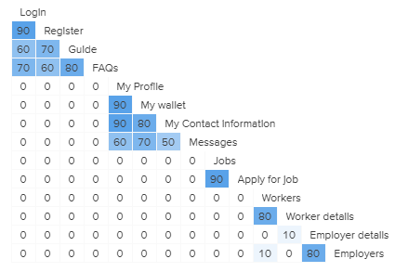

Figure 4

### Dendrogram:

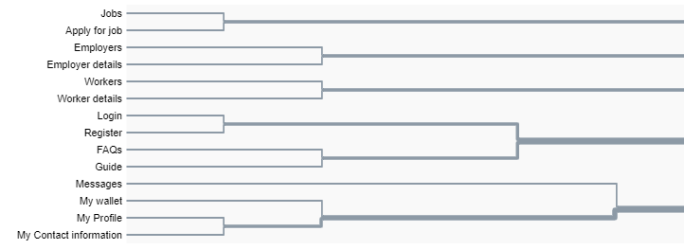

Figure 5

**NOTE:** The implementation that reflect findings from each set of data gathered is justified under section ‘Design Decisions’ later in this report.

## Prototype

The most basic definition of “prototype” is, “A simulation or sample version of a final product, which is used for testing prior to launch.” The goal of a prototype is to test products (and product ideas) before sinking lots of time and money into the final product.

After carrying out all the necessary studies, it was time to build prototype of the website. The website was going to have many pages but the most important one was the “Profile” page where user’s information and other details were supposed to be displayed. If the user is employer, then through “Profile” page he/she is supposed to post the job. As you can see that the “Profile” page is going to be an important part of this site, I decided to build wireframe of just this one page because building wireframe for each page would have been a lot of work. Below you can see the prototype design for “Profile” page:

**NOTE:** The prototype is for “Profile” page only, final website includes implementation of all the required pages and functionalities**.**

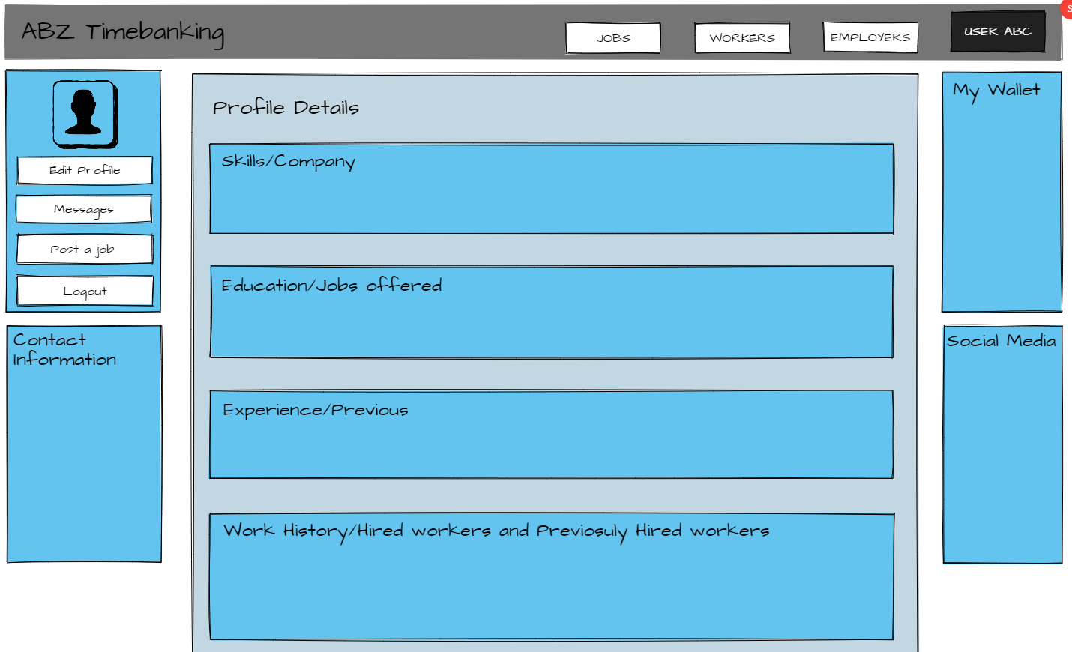

Figure 6

## Evaluation

* The above prototype was supposed to display all the information that is presented in survey questions 7, 8 and 9. All the information from these questions would be displayed in their appropriate boxes on the profile page but, it does not include the employer/worker reputation box which would show review and remarks given by other people to that particular employer/worker. Because of this reason a “reputation” box needs to be made in final website.
* The prototype also abides by the data gathered in card sorting study which showed that My Profile, My wallet, Contact Information and Messages were grouped together by more than 50% of users. This meant that these 4 key sections should be on one page.

## Treejack

Treejack is a service provided by **Optimal Workshop [1]** where research team can work on their workflows to be carried in their website. This is a very useful tool as it enables the developers and researchers to evaluate their navigation system that they need to implement in their website. For this particular time banking website, we organized a Treejack study. This study asked the users to navigate through the pages of website using Treejack and find a particular piece of information. All the users had tasks to do mostly about finding required data. The Treejack looked like this:-

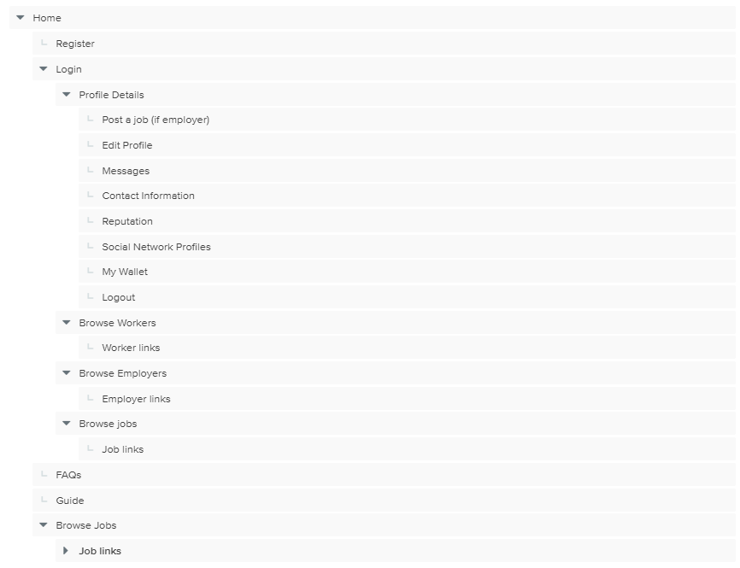

Figure 7

The following tasks were given to each user and the result for the study was analyzed using different forms. For this particular study we used pie charts to demonstrate the success ratio. The findings from all three tasks is presented below:-

### Navigation task results

**TASK 1: Browse job links after logging into the website.**

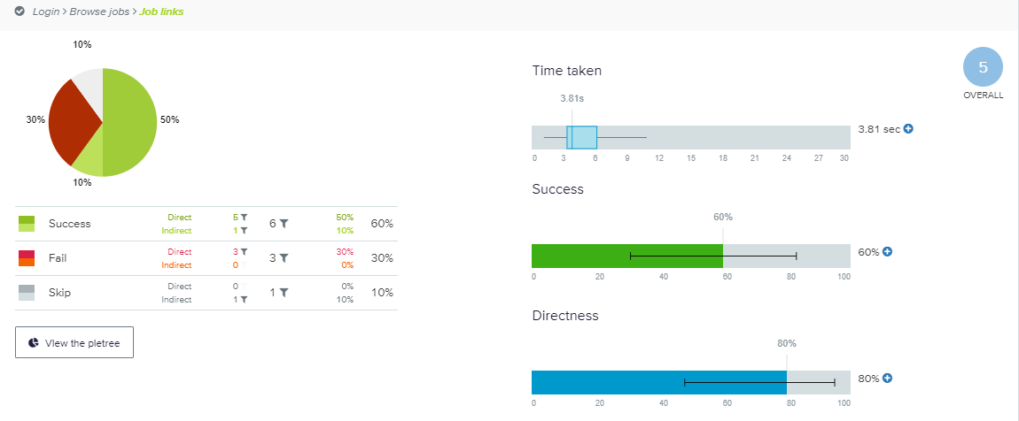

Figure

**TASK 2: Post a job after logging.**

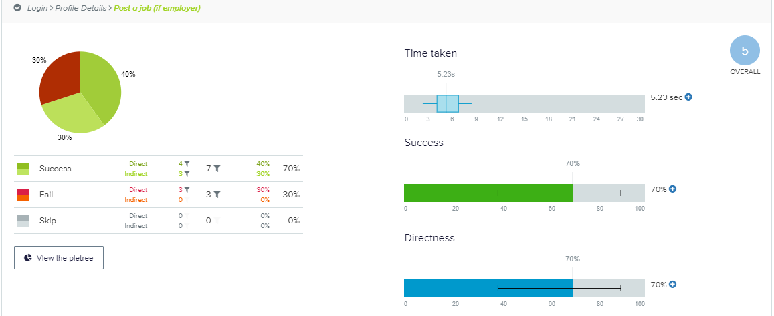

Figure

**TASK 3:** **Where can you find your wallet?**

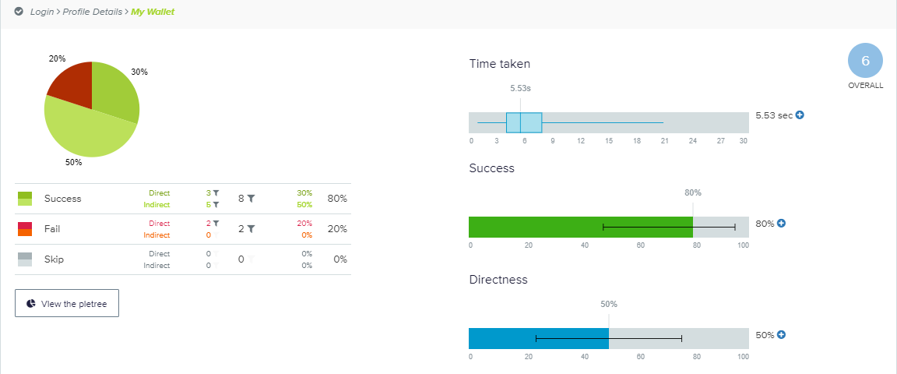

Figure

As you can see that all three tasks were performed correct by most users (=>5 score), this designed navigation was implemented later in phase 2.

**NOTE:** The implementation that reflect findings from each set of data gathered is justified under section ‘Design Decisions’ later in this report.

In the following section you will get to know the reason behind some of the design patterns and design decisions taken to implement this website:-

## Design Decisions

1. As this website was not going to be a one-page website, we had to adopt a navigation principle. **Primary or Main navigation is top navigation bar. Local navigation is vertical navigation bar [3].** This arrangement is also called an inverted-L. Looking at the dendrogram in figure 4 we knew that there were 5 major groups forming but these groups were mixed with each other interchangeably. So we designed a navigation system and tested our design in the Treejack study. The main root had all the elements which were supposed to be on top navigation bar. All the children nodes were supposed to be on vertical navigation bar because those were local. It gave us satisfactory result and thus we implemented the mentioned navigation principle.
2. **Home page: Login, Register, FAQs and Guide**. If we look closely into the results of card sorting by analyzing the similarity matrix shown in figure 4, it is quite clear that these 4 elements were grouped more than often with each other and they all were coming from root node. And keeping this in mind that all the elements who come out of root node makes the home page of any website, these 4 were chosen to be on home page of our website.
3. **Login and register on same page.** 90 percent of people grouped login and register together according to the similarity matrix in figure 4. This led us to architect login and register forms on a single page.
4. **Separate employer and worker account.** This was one of the major decisions we had to take. According to the survey where we distributed a Questionnaire, this was obvious that not everybody wanted to be an employer and worker at the same time. According to results of question number 5 on the survey, only 20 percent of people want to employ someone and be a worker too. This helped us make the decision of making employer and worker as two separate users.
5. **Profile page filled with information only that is needed by the users.** Questionnaire and Treejack reference. According to the questionnaire’s result, the information that needed to be on profile pages of users has been determined. Question number 8 and 9 explicitly asks the users about the information they require for both employers and workers respectively. While question number 7 asks the users to list general information they need for all the users. For example in Question number 8, 80 percent users did not want to know about worker’s salary beside this platform so we did not added it in our design.
6. **Separate workers, employers and jobs browsing area.** We could clearly see from the results of card sorting that workers ,employers and jobs were grouped separately very often .This forced us to make a design where these 3 elements would have their own section and be represented by their own separate pages. After coming up with this solution, we tested it in Treejack study and realized that this was good idea as most people navigated to right area even though the navigation system had separate paths for these 3 elements.
7. **Responsive Web Design.** Question number 10 on our questionnaire survey raised some very important points. This website should be useable not only on desktop but also on the phones of users and hence making it responsive was something mandatory to do.
8. **Accessibility.** Users can access jobs page without registering**.** The main reason for this project is that people can see what the demands are and what they can offer to the community. Users can access jobs page without registering. All required pages and information is easy to find and accessible to relevant user.
9. **Messaging service**. Employers and workers can communicate on the website as well. This was a hard feature to implement but as required by the users (Survey Question no. 4), it was necessary to build it.
10. **Job application service**. When a worker apply for a job, a row is inserted in the database table which holds the records for all the applications. It was necessary to implement the job application functionality in order to track who applied for which job.

# Phase 2: Implementation

This phase was for the development of website on the basis of user data and design decisions taken. Now we had the user data generated by our studies, we needed to design a layout which would present the information architecture in a way that is acceptable and convenient for most of our users. We implemented all the features that were mentioned in coursework specification; account creation and login; time banking related functionalities and usability of website. Besides the required functionality, there were many more things which were implemented, some are mentioned in ‘design decisions’ section of phase 1 and other would be visible on the actual website.

## Heuristic Evaluation:

For heuristic evaluation of this website, I have taken reviews from 2 usability experts (subgroup 2 – Muhammad Kaab and Gregory Biro). From functionality point of view, all the requirements were satisfied – Register, Login, Job posting and member search. Besides these, messaging service, job application monitoring, navigation facility via footer, information display on footer etc. were also implemented.

From usability and user experience point of view, following key points were raised:

* On the Homepage the area which mentions the diverse categories of jobs on the website, directs it to a page where all kinds of jobs are being listed and not just the jobs according to the specific category chosen.

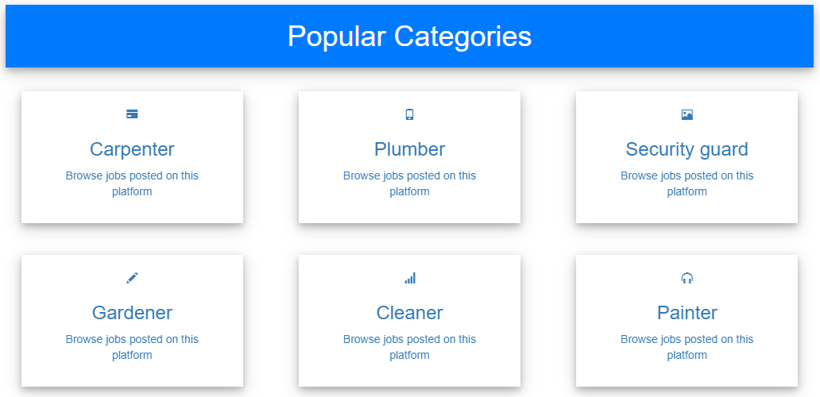

Figure - Part of Homepage

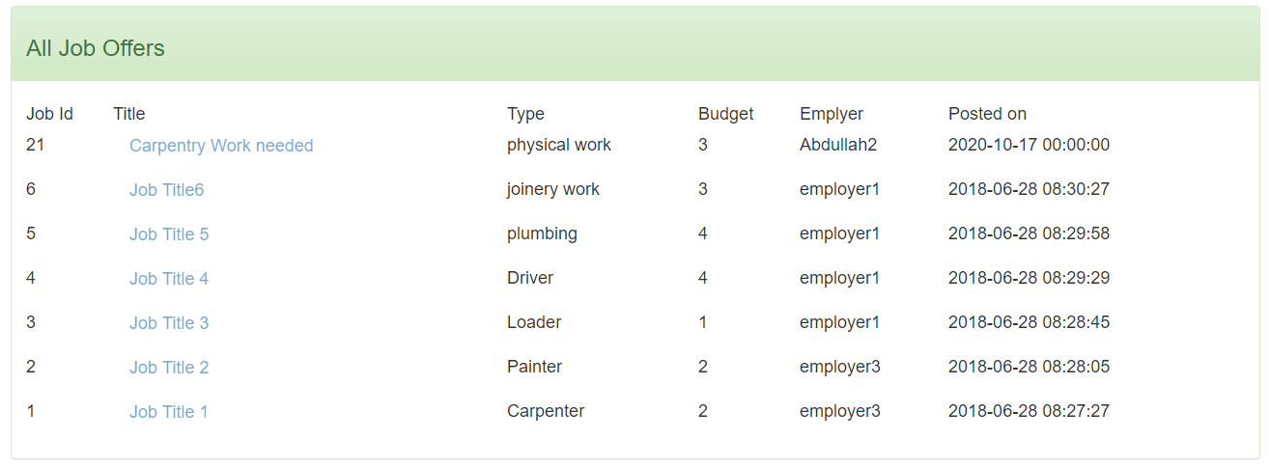

Figure - Directed page (job search page)

* The buttons used on Login and Register page seemed bigger than they should be. Form field requirements were not compromised and taken care of efficiently.

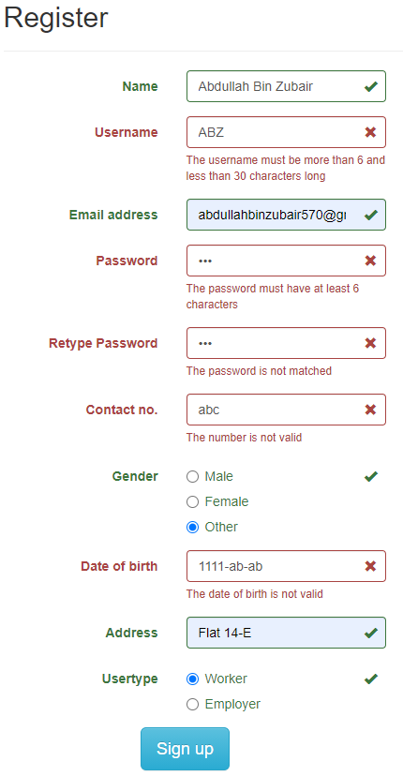

Figure

* Profile page information architecture was well built and maintained. There seemed to be no negative remark about the profile page.

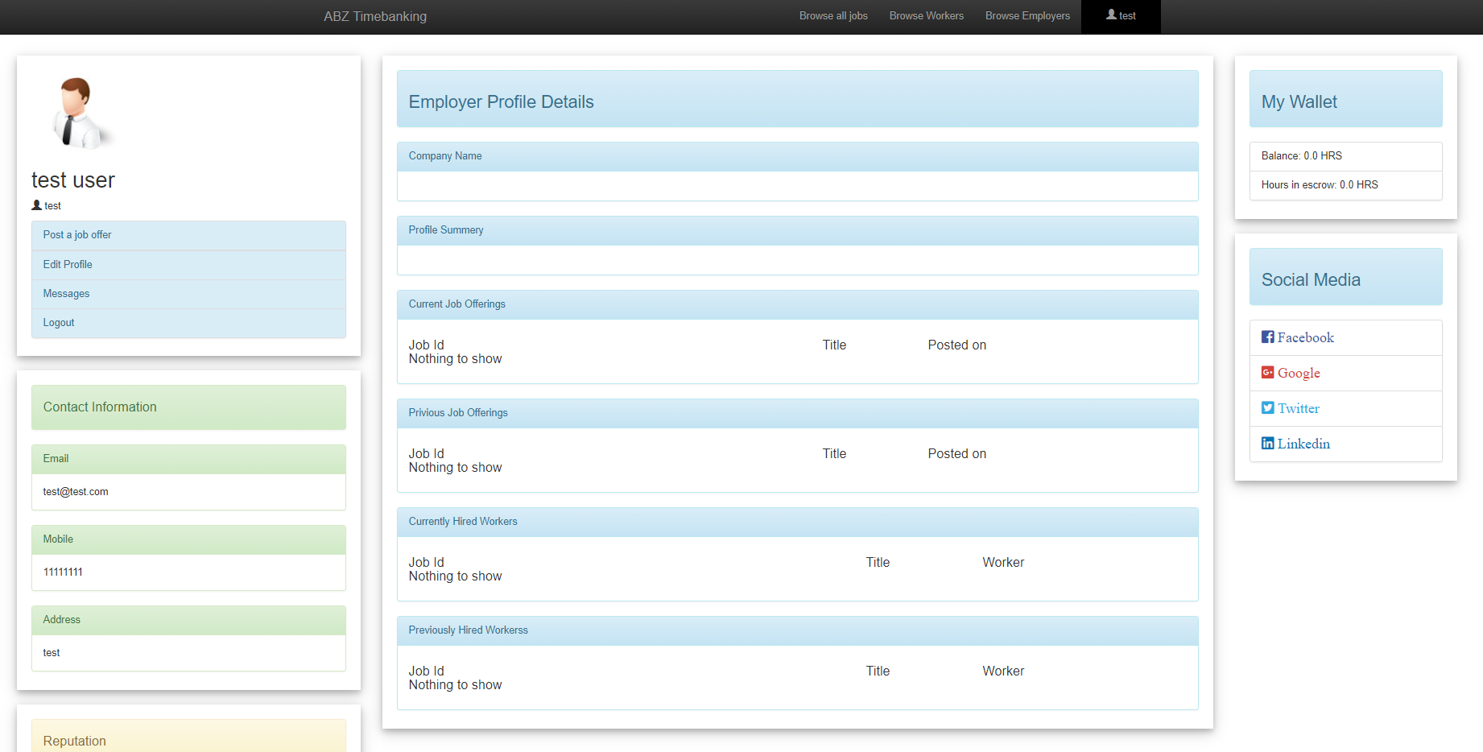

Figure - Profile page

* Worker and Employer search pages were well organized and searching was enabled on basis of different user attributes i.e. name, username etc.

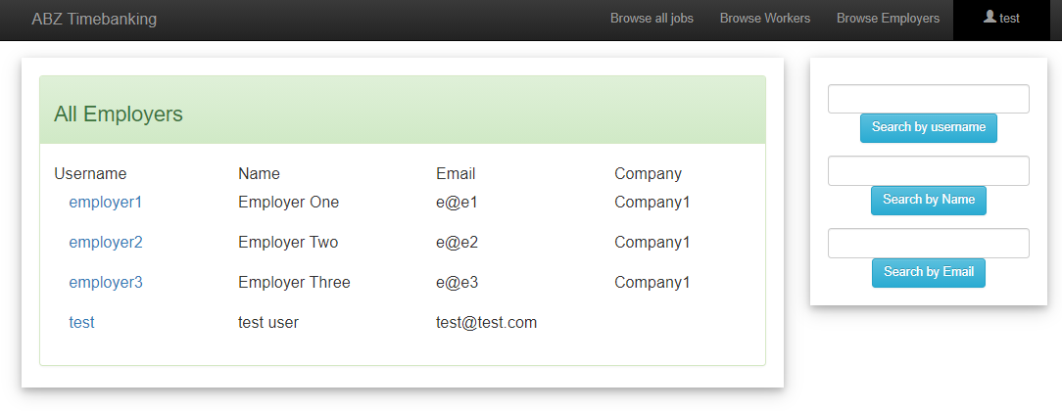

Figure

* Job search page was also well organized and search was enabled on basis of different attributes here as well.

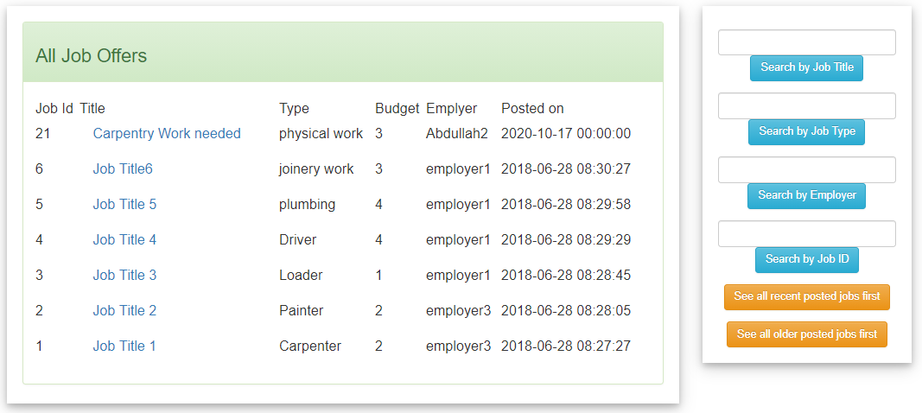

Figure

* The messaging page and profile editing pages were simple and provided information to the point.

### Employer account

Username: test -------- Password: test

### Worker account

Username: worker1-------- Password: 111111

**NOTE:** I had named worker database table as “freelancer” to make things clear for myself in the beginning of development phase. It’s just the word used for “worker” in my database.

In case of any query or confusion, feel free to drop an email at [az5645a@greenwich.ac.uk](mailto:az5645a@greenwich.ac.uk).

# References:

1. Optimal Workshop Research Tool. Available at: <https://www.optimalworkshop.com>
2. <https://www.interaction-design.org/literature/article/personas-why-and-how-you-should-use-them>
3. <https://www.oreilly.com/library/view/designing-web-navigation/9780596528102/ch04.html>

# Code references:

1. <https://w3schools.com> --- taken code from various portions of this site.
2. <https://github.com> --- taken code from various projects on this site.